Solving DE using Power Series Method

EXPERIMENT - 6

CODE: -

clear all

clc

syms x c_0 c_1 c_2 c_3 c_4 c_5

p1x = input('The coefficient of D2y :');

p2x = input('The coefficient of Dy :');

p3x = input('The coefficient of y :');

c = [c_0,c_1,c_2,c_3,c_4,c_5];

y1 = sum(c.*(x).^(0:5));

y=y1;

dy=diff(y);

d2y = diff(dy);

ode=p1x*d2y+p2x*dy+p3x*y

ps=collect(ode,x);

d = coeffs(ps,x);

[c_2,c_3,c_4,c_5] = solve(d(1),d(2),d(3),d(4),c_2,c_3,c_4,c_5);

z = subs(y);

disp(' The general solution of the given ode around x=0 is given by: ')

disp(z)

i1 = input('enter y(0) :');

i2 = input('enter Dy(0):');

zz = subs(z,[c_0,c_1],[i1,i2]);

disp(' The Particular solution of the given ode around is given by: ')

disp(zz)

ezplot(zz,[-4 4])

Input 1: -

Question 1: -

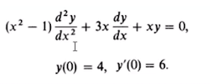

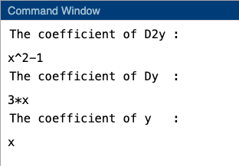

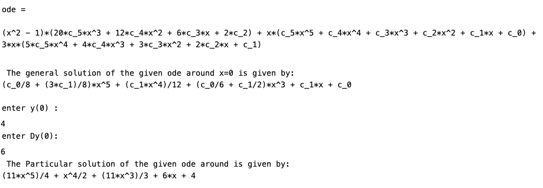

Graph: -

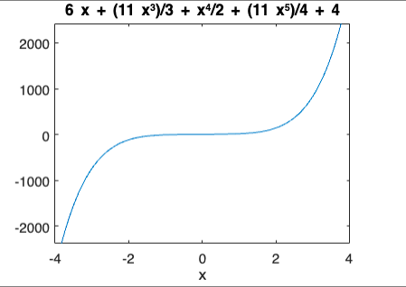

Input 2: -

Question 2: -



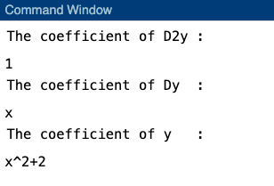

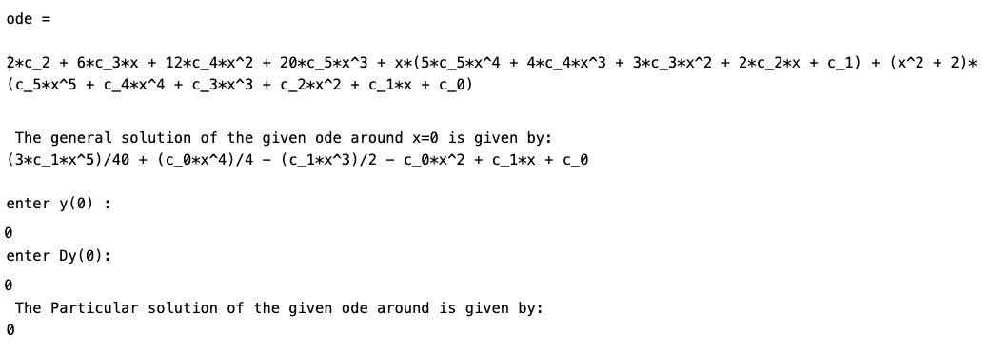

GRAPH: -

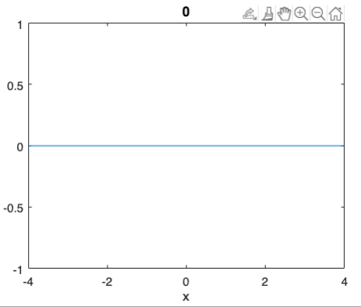

Input 3: -

Question 3: -



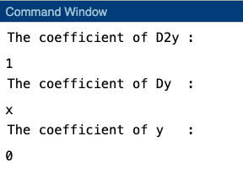

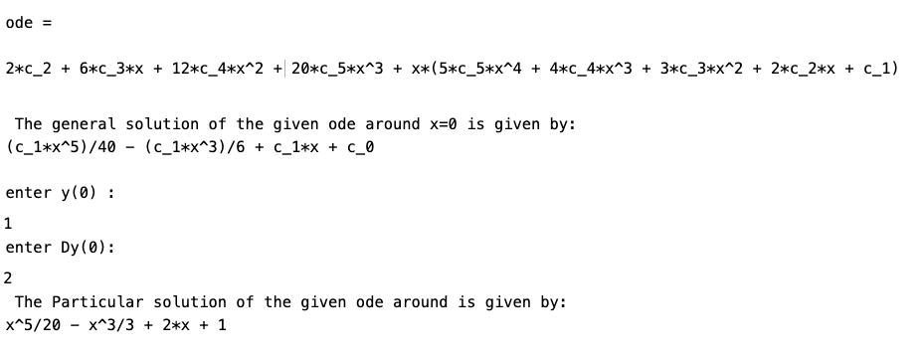

GRAPH: -

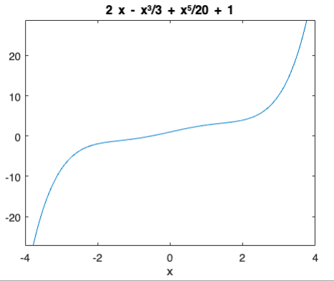

Input 4: -

Question 4: -



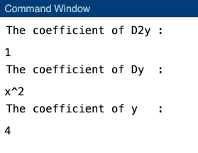

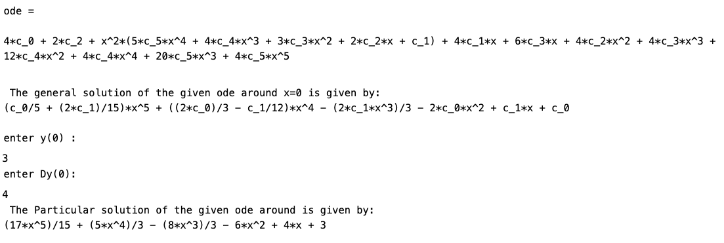

GRAPH: -

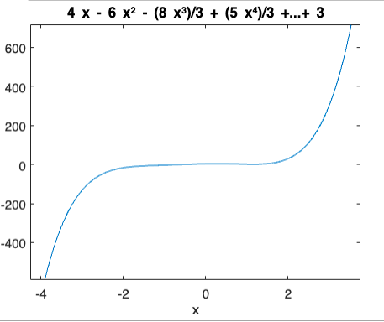

Input 5: -

Question 5: -



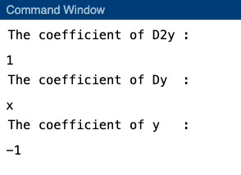

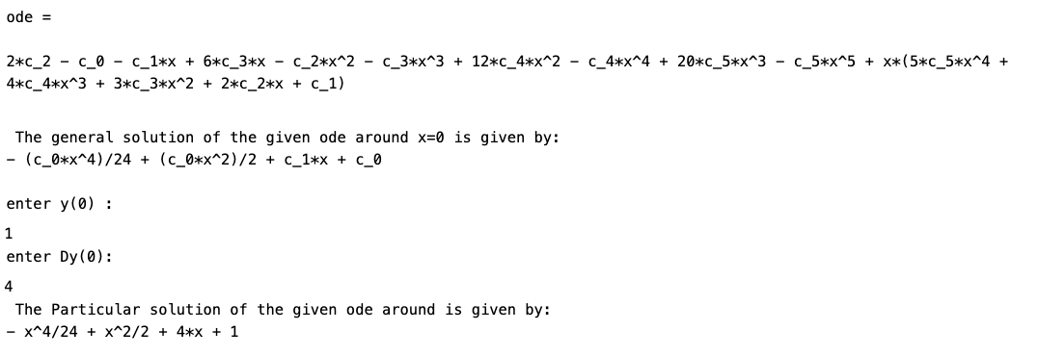

GRAPH: -

